Al-Anon's District 1 Picnic
At
Creek Ridge Park
July 22, 2017
At 12pm till Whenever
Speaker is: Denise S.
The district will supply the chicken, the drinks, the plates, napkins, and silverware. Bring a dish to share.
Bring a white elephant gift to exchange.
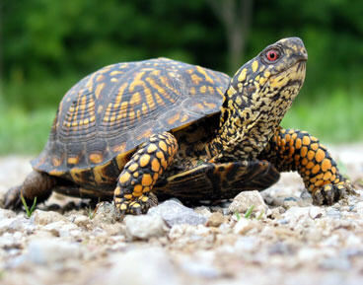
There will be games to play. We will have a volleyball for anyone that wants to play because the park has a net up. Their will be a bingo game.
Creek Ridge County Park
7943 W 400 N
Michigan City, IN 46360
From Highway 65 ---
Take Highway 65 to Exit 259B towards Detroit(East)
Turn onto Highway I-94 towards Michigan City
Turn onto Exit 34B(US - 421North) Michigan City
On US -421N(Michigan City) go straight to first stop light
At stop light turn right onto 400 N
On 400 N you will stay straight on this road
(You will pass the surgery center and doctors offices)
You will go over a bridge and curves
Once you curve -- you will be at the park in a 1 or 2 minutes
On the right side of the road -- you will see the sign
When you see the sign -- you will turn left into the park
(On the left side -- you will see a gate -- this is where you turn into the park)
After you turn into the park -- you will go through trees before getting to the parking lot
Once you see the parking lot -- turn right into the first parking lot
Park at the end of the parking lot -- this will be where the shelter is. (You will see the kids playground on the left side)

